Bert Is Evil

Collected here are documents and images that show that Bert is Evil. Many of these documents were submitted by anonymous sources who choose not to be revealed. All the files have been verified and cross-referenced with the FBI and other Intelligence Agencies.

The following files may contain graphic information, please proceed with caution.

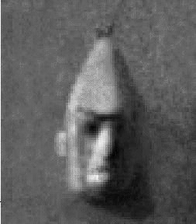
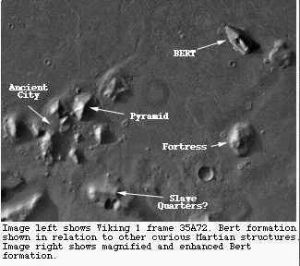
On July 25th, 1976, this picture (frame 35A72) of the Cydonia region of Mars (at 41 deg. N latitude 9.5 deg. longitude) was photographed by Viking Orbiter 1. The mission was to identify potential landing sites for the Viking Lander 2. As you can see this landform bears a striking resemblance to the evil Bert. This photograph was suppressed by higher-ups in our government and an alternate landing site for Viking 2 was selected.
What conclusions can we draw from this image? First of all, the only life forms that we know of that developed on Mars were single-celled organisms. Considering the immensity of this formation (2.5 km long x 2.0 km wide x 0.4 km tall) it becomes immediately apparent that the logistics of single-celled organisms building such a stone monument to Bert are mind boggling. Why, it would make the construction of the pyramids at Giza look like a sand castle building contest. According to the facts as I have presented them, ancient Martians by the billions were obviously enslaved by their Bert-worshiping overlords for this project. But why? Is it a mute testament to the devotion of a long dead race to the evil Bert (whom they must have worshipped as a god)? Is it a warning of some kind? As if to tell humanity that we are not welcome in space, that we should go no further? And why Bert? We have no record of a Bert before 1969, and yet here he is immortalized on a rock formation believed to date back to some time between Earth's Precambrian era and the late mezzanine level. Did Bert somehow time travel and convince the ancient Martians to do his bidding? Is it possible that a visionary Martian microbe looked into the future, saw Bert, and was so affected by the evil images that washed over him that this single-celled Nostradamus was compelled to put his visions to rock? I know not. But clearly spending a lot of money on costly Mars probes to investigate this further is warranted.

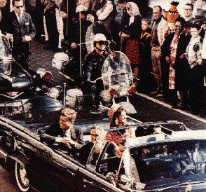
In this rarely seen photo, we see Bert standing in the sidelines a few seconds before the assass-ination of John F. Kennedy. We have sources who claim that Lee Harvey Oswald and Bert were friends in Korea. Though no proof directly points to Bert's involvement in this ghastly shard of history... we wouldn't be too surprised if he was.

This shot was taken from a Dutch episode of the "Jerry Springer Show" which was (according to the newspapers) banned from network television stations in the USA. It appears Bert is harassing innocent people from the opposite sex. And being confronted with this fact on national television Bert attempted to rape the two girls just hours after the show was recorded.
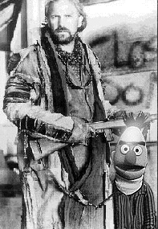
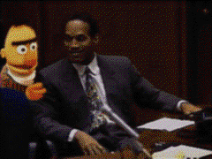
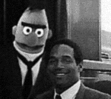
It is a well kept Hollywood-secret that ("actor/director") Kevin Costner, after finishing the "Dancing with Wolves" movie, wisely planned to retire from the movie-business and prepared to move to northern Alaska to spend the rest of his life apart from the rest of humanity. It is an even bigger secret that Bert finally convinced Costner to stay in Hollywood. He talked Kevin into making more horrible movies such as "Waterworld", "Robin Hood" and, his latest crime, "The Postman". This final movie is even co-produced by Bert. This shot is taken on the set of "The Postman" when Costner was taking advise from Bert on how to act in a post-apocalyptic world

Dear Sir, Enclosed you will find a couple of snapshots of Bert conspiring with that infamous ex-football player, ex-moviestar, ex-husband and axe-murderer, O.J. Simpson. It's a well-kept secret that Bert was actually part of O.J.'s defense team during the first trial, and was also the only person in whom O.J. fully confided. Interestingly enough, photograph no. 2 was taken exactly ten minutes before the murders took place. (Also, did you know that yellow lint was found at the crime scene? It's true! It was exhibit no. 156a during the first trial). I know I am putting you and myself at risk for giving you all this information, but the truth must not be stopped. What are a few casualties for the good of man and muppet-kind? Use this information well, and good luck.
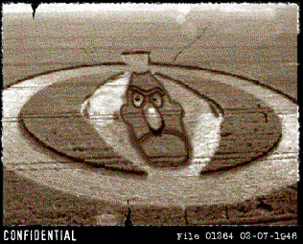
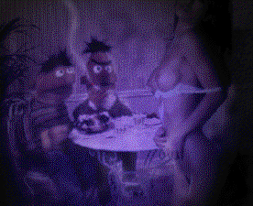
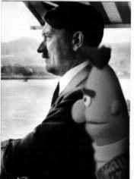
For months I tried to hack the FBI crop circle files because an anonymous friend told me about a crop circle in the shape of Bert's head. Yesterday I finally made it in. This picture was taken back in 1948, because crop circles weren't very common back then, local authorities didn't file it. After a few years the FBI found it in a private collection of a local police officer. He died two months later in a train crash. Why the FBI tried to hide this evidence, I'm not sure. Maybe they already knew about Bert's links with the extra-terrestrial. We caught Bert dragging Ernie out of their apartment in Sesame Street and decided to follow to where they were going. We were shocked to find the two in a Girlie Bar. Bert was forcing Ernie to get lap dances from all the ladies. Poor Ernie went home crying. During World War II, General Berhtolomue Kieffer III lead the SS in the burning of the Reichstag. He is known to be one of Hitler's most diabolical Generals. We have reason to believe that he is either a clone or an ancestor of Bert

