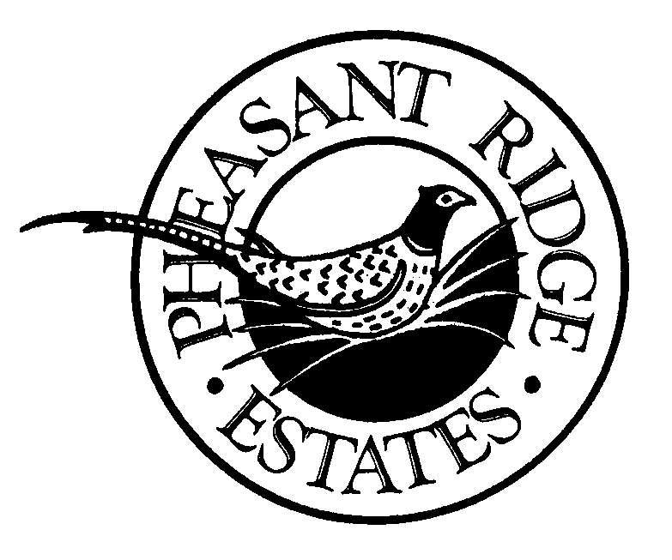

PRIVACY POLICY

What this Privacy Policy Covers

- This Privacy Policy covers Pheasant Ridge Estates, Inc. (“we/our/us”) treatment of nonpublic personnally identifiable information that we collect when you, the “customer” or “consumer,” finance the purchase of a manufactured home from us. This policy also covers our treatment of any nonpublic personally indentifiable information that our business partners share with us.

- This policy does not apply to the practices of nonaffiliates of Pheasant Ridge Estates, Inc.

Information Collection and Use

- We collect nonpublic personal information about you from the following sources:
- Infromation we receive from you on applications or other forms;
- Information about your transactions with us, our affiliates, or others; and
- Infromation we receive from a consumer reporting agency.

Information Sharing and Disclosure

- We do not disclose any nonpublic personal information about our customers or former customers to anyone, except as permitted by law.

Confidentiality and Security

- We restrict access to nonpublic personal information about you to those employees who need to know that information to provide products or services to you. We maintain physical, electronical, and procedural safeguards that comply with federal standards to guard your nonpublic personal information.

By signing below, I acknowledge that Pheasant Ridge Estates, Inc. provided me with a copy of it’s Privacy Policy.

___________________________________________ Date: __________________
Consumer/Customer

