The Only Good Sectoid



Is a Dead Sectoid

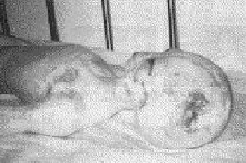

Do your part this Earth Day.

Earth Day 2001 Brought to you by A.T.H.E.N.A

