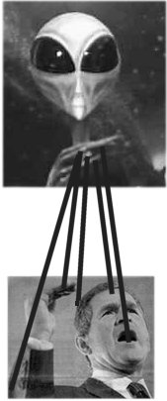

PUPPET! PUPPET!!

Earth Day 2001 Thanks ATHENA!

