What’s Wrong with this Picture?



It Doesn’t Look Like this One:

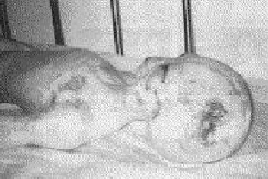

Do your part this Earth Day.

Brought to you by A.T.H.E.N.A

