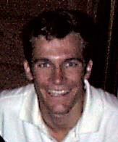
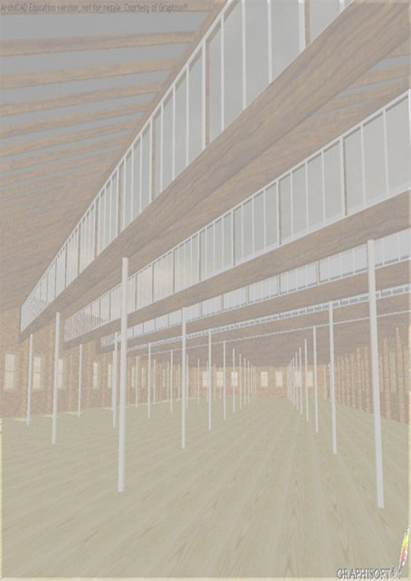
Name: Matthew Robert SIMPSON.
Address: PO Box 4120 6/162 Swann Rd
St Lucia South Taringa
Brisbane QLD 4067 Brisbane QLD 4068
Telephone: (07) 38760082. Mobile: (0414) 364082
Date of Birth: 14th March 1978. Health: Excellent.
Licence: Current Queensland drivers licence, Open, Class C.

Education:
Currently enrolled at the University of Queensland:
Bachelor of Architecture: Fourth Year (year out compulsory work experience)
Completed Bachelor of Design Studies: 1998.
TAFE Queensland “ Bar Services Practices” Course: December 1997.
Mullumbimby State High School (NSW): 1990 – 1995.
Mullumbimby Public School (NSW): 1984 – 1989.
Hornsby Heights State School (NSW): 1983.

School Courses: Board of Studies Courses Completed:
Tertiary Entrance Rank (TER): 91.55 (equivalent of an OP 4)

Higher School Certificate (1995)
English A Mathematics(C) A
Economics A Physics B Engineering Science A

Work Experience:
At Present: Currently employed as senior tutor at University of Queensland in the facilities of Architecture and Information Environments., teaching ArchiCAD and studio design.

At Present: Also presently working on two private residential renovations/additions including design, drawing, submitting to council, co-ordinating and assisting in construction.
August 1997 to March 1999: Employed by Jimmy’s at The Mall, (Queen St Mall, Brisbane) restaurant and café in a management supervisory position from.

September 1997: Runner-up in application for position of Architectural (Student) Consultant and Designer in Project Services, Department of Public Works and Housing in the Queensland government.

March 1992 to August 1995: Held a job of responsibility at Mallams Foodstore in Mullumbimby (supermarket) for three and a half years as a permanent casual.

May 1993: Conducted work experience in the Byron Shire Council Chambers in the Town Planning Department.

Various photographic experience, including work at weddings and other formal ceremonies.

Interests and Hobbies:
* Expressing Creative Skills:
As I am studying to become an architect, major hobbies are concerned with my area of study. Drawing and sketching are two of my hobbies, along with photography, of which I am very keen. I also have two years of extensive experience with computer drafting and modelling in ArchiCAD and associated programs.

* Participating in the Team Environment:
Hockey, Touch Football, and Water skiing are sports I enjoy and participate in regularly, being a member of several sporting teams.

* Outdoor Activities:
I am a very active person and enjoy a wide range of outdoor and physical activities as mentioned above. Travel, I feel is an important learning tool helping to broaden one’s horizons. This resulted in my travels to England, France, Hong Kong and Singapore.

“I always enjoy a good challenge and never give up, not without a good fight at the very least. If a job is worth doing, it is worth doing properly.”
Matthew R. Simpson 1995
Referees:
Mr Michael Docherty BArch MArch MACS Mr Michael Kenniger
19 Rennie St University of Queensland

Indooroopilly QLD 4069 Brisbane QLD 4072
Australia Australia
(07) 33653239, (0419) 704801 (07) 3365843

References:
Mr Bernard Matthews Mr Peter Floyd
Great Witchingham Hall PO Box 123
Norwich, Norfolk Mullumbimby NSW 2483
England NR9 5QD Australia
(1603) 872611 (02) 66841325

